
PROJECTS APPLICATION FORM
BASIC INFORMATION
Type of study
Observational Study with Medicines( EOM ) ! If it is a prospective study, please complete the attached documents section at the end of the document
Prospective (subjects are followed for a period of time until it becomes the result variable, and
this has not yet occurred at the time of the start of the study)
Retrospective
Clinical Trial with Medicines
Clinical Research with Medical Device or others (cosmetic, nutritional product)
Research Project
Project Title:
Short title or acronym |  |  |  |  |  |  |  |  | Protocol Code
Version and Date of documents
Protocol version |  | Protocol date
PIS and IC version |  | PIS and IC date
Principal Investigator (coordinator of the study)
Name and surname |  |  |  |  |  |  | Email
Work centre
If the PI is not from Primary Care (PC), the person in charge of PC must be specified
Name and surname |  |  |  |  |  |  | Email
Work centre
IMPORTANT: In order to receive the automatic communications that are made from the system in relation to the evaluation by the CEIm, the IP of the project must be registered in our system: https://portal.idiapjgol.org:6443/gir/login/index.php?entorn=IDIAP
(*) Profession of the PI (fill in only in PC PI)
Family Medicine  Nurse  Paediatric  Gynaecology  Odontology  Psychology |  |  |  |  |  | Nutrition  Physiotherapy / Rehabilitation  Social Work  Pharmacology / Pharmacy  Other:
Research Team (name, surname and work centre):
PIs from Participating Centres (Fill in the case of prospective EOM, Clinical Trial with Medicines, Clinical Research with Health, Nutritional or Cosmetic Products)
Name and surname |  |  | CAP (Work Centre) |  |  |  |  |  |  | Profession (*)
In case you need more rows, fill in the requested information here, separating each value with a comma (,) and each person with a hyphen (-)

SUMMARY OF THE STUDY
PROMOTOR/ FINANÇAMENT DE L’ESTUDI
Promoter of the study (It is the natural or legal person who has an interest in carrying out the study. He is responsible for the project, including the organization, initiation and financing. The status of promoter and Principal Investigator may be concurrent in the same person).
Entity:
Name and surname contact person:
Email:
CRO of the study (if applies) (Natural or legal person hired by the promoter to perform functions or duties of the promoter in relation to the study)
Entity:
Name and surname contact person:
Email:
Funding Source
Public Amount: Name of the funding entity:
Private Amount: Name of the funding entity:
No Funding
Competitive Call
The project is associated with a competitive call: Yes No
If so, which one?
Situation: It is already presented It will be presented soon It has already been granted
The call was managed from IDIAP? Yes No
If not. The IDIAP will receive some economic items? Yes No
European Internacional Project
It is an Europeu project? Yes No
Costs
It involves an extra activity to the usual practice, which involves a cost (e.g. analysis, complementary tests, etc.)? Yes No
If so, who bears the costs?
In the case of an industry study, specify whether there will be payments to the research team
With payment to the research team
Without payment to the research team
STUDY METHODOLOGY
Period of the study | Year Start: Year End:
Study design
In case of mixt methods (quantitative i qualitative) mark both options
Quantitative Methodology Qualitative Methodology
Clinical Trials Qualitative studies
Randomized individual
Randomized by conglomerates
Controlled not randomized (pre-post)
Not Controlled
Observational Studies
Transversal Cas – control Cohorts
Diagnostic test evaluation studies
Validation studies of measuring instruments
Others: (specify)
Objective of the intervention or exhibition
Problem to be treated or product on which we will base our intervention or exhibition
Medicines (use of medications, adverse effects, or safety of a medication)
Disease (epidemiology of a disease)
Medical devices
Medical equipment (products for topical care/treatments)
Medical Equipment (machines such as C-pap, ...)
Technology: Apps...
Nutritional Product
Cosmetics Product
Interventions (specify): Educative Technology
Others: (specify)
Research area  Services Research  Mental Health  Lifestyles  Active and healthy ageing  Mother and son  Childhood and adolescence |  |  |  |  | Cardiovascular  Diabetes  Infectious diseases  Musculoskeletal System  Respiratory  Cancer  Others:
Does it include the perspective of citizens? Yes No
Participation of patients, associations (of any kind such as education, activists, ...), policy makers and other key agents who contribute to providing experiences and other views on the phenomenon of study in some or all phases of the research project. Participation is understood not as study participants but as people who have an active role throughout the execution of the project together with the research team.
CEI ASSESSMENT
In the case of studies with medicines, indicate the reference CEIm:
Has the project been previously evaluated by the CEIm of the IDIAP? Yes No
If so, indicate the CEI code or IDIAP code:
Is it a sub-study of a project that has already been evaluated? Yes No
(they are specific protocols of sub-studies or different work packages within a main project, which due to the limited format of the call has not been possible to develop the complete protocol, but this also needs to be evaluated by the CEI)
If yes, please tell us the code of the first project:
If you do not remember the code, please indicate the title of the previous project:
DATA PROCESSING
To process personal data, it is necessary to have a legal basis. This legal basis can be patient consent, public interest in research or others provided for in the regulations, such as the reuse of data or the use of data by a public health authority, in an emergency situation. For practical purposes, to be able to use data for scientific research, we either have the consent of the owner, or the data is pseudo-anonymised.
Data Source
Primary Data
Data obtained from patients (CI required) (PIS and IC must be attached)
Secondary Data
Data from the Clinical Health Records (extracted automatically)
SIDIAP (! remember that you must fill in the specific sub-section)
Other Public registries
Data from previous research (in the case of SIDIAP, it does not involve new data extraction). Indicate which project the data will be reused from:
Data collection and Security
A data management platform/CRD is used (p.e. RedCap, Lime Survey, Teleform, etc.)?
Yes No
If so, Which?
Where the data will be stored?
Artificial Intelligence or High-risk situations
Use of innovative technologies (artificial intelligence techniques, wearables or apps, virtual reality systems, geolocation or biometrics), treatment of particularly vulnerable groups (minors, disabled), data profiling or mass data processing

There is a high risk in data protection Yes No
Does the project contain any AI elements? Yes No
If so, which:
If so, in either of the two previous cases:
Has an impact assessment been carried out? Yes No (you must attach the document)
Data controller and data processor It can be more than one. In this case, detail it
Who is the data controller?
Natural or legal person, public authority, service or any other body that, alone or jointly with others, determines the purposes and means of the processing; When two or more controllers jointly determine the objectives and means of the processing, they are joint controllers.
Example: When it comes to data from the Medical History, the ICS is responsible; in the case of a QRD or survey when the information is entered by the patient, the person responsible would be the entity of the principal investigator

Is there another person responsible? Indicate it/s:

Is there a person in charge of data processing? Yes No
Natural or legal person, public authority, service or any other body that processes personal data on behalf of the data controller.

If so, identify it:
Services to be performed:
Example: statistical analysis, genetic sequencing, transcriptions.
The services to be performed must be specified in a contract.
Data transfer
It occurs when the personal data that is processed by a data controller or a data processor is sent to an external entity, different from the above.
When this transfer takes place outside the European Economic Area (EU, Iceland, Liechtenstein and Norway) and the data is sent to a third country or international organization, outside this territory.

Is there a data transfer? Yes No
If so, Recipient of the transfer:

Is there an international transfer of data? Yes No
If so, recipient of the international transfer:

SIDIAP INFORMATION ! Fill in only for SIDIAP projects

Common data model
SIDIAP OMOP VAC4EU
Data to be requested
Basic data
Socio-demographic variables
Health problems
Clinical variables
Laboratory Variables
Pharmacy
Pharmacy dispensation
Prescription
Other
Referrals and Clinical Orders (complementary test)
Second-level Variables (variables of professionals, Centres, etc.)
ASSIR - Paediatrics
ASSIR Variables
Paediatric Variables
Algorithm Mother-Son
External Sources
CMBD-AH
CMBD-AH (Minimum Basic Data Seron Hospitals Discharges. Data from 1990)
Other data of the PADRIS Program
CMDB - SMH (Monographic psychiatric hospitals. Data from 1995)
CMDB - SMA (Outpatient Mental Health Centres. Data from 1998)
CMDB - RSS (Social and Health Resources. Data from 1999)
MHDA (Outpatient Hospital Dispensing Medicines)
Dats sources of the research team
BD of the research team
Specify the name of the source and briefly detail the variables it contains:
Other sources (e.g. Cancer, Dementia registries, RACAT, etc.)
Other Sources
Specify the source name:
Sources of data to request from the National Statistics Institute (INE)*
Mortality
*This data has a specific cost when purchased from the INE, which depends on the sample size (N) and the complexity of the data to be cross-referenced. The extract amount is not known until the agreement is signed. The procedures to obtain the data usually take approximately one year.
Matching
Is it necessary to make patients matching: Yes No
Follow-ups
The project will require more than one delivery: Yes No
If yes:
From the same cohort
From the same cohort with External Sources
Change in population or variables (including external sources)
Specify the number of deliveries: and the years of delivery:
USR REVIEW (only for centres ICS)
Reviewed by: (Name and Surname of the person from USR who reviewed the protocol)
USR:
Observations:
The PI of the project is obliged to inform the director of his or her centre of the completion of the study

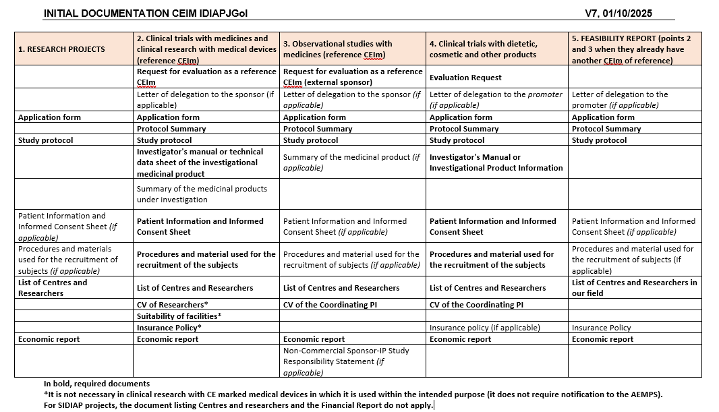
ANNEX

